SAMPLE REQUEST FOR CORPORATE SPONSORSHIP
Kellogg Evening & Weekend Program

This document is to be used as a tool and framework for you to engage your employer
in sponsoring your attendance in Kellogg’s Evening & Weekend Program.
To build the best case possible for your employer, we strongly encourage you to adapt this document so that it’s reflective of your voice, your relationship with and understanding of your company and the specific benefits you and your company will receive from your participation in
Kellogg’s Evening & Weekend Program.

CONTENTS
- Letter of Intent
- Summary of Candidate’s Qualifications
Current contributions to the company
Professional development goals at the company
- Why a Kellogg Evening & Weekend MBA
Program overview
Program format
What distinguishes Kellogg
- Why now
Resources, skillset & network for disruption
- Return on investment
Curriculum & faculty
Programs & electives
Peer network
Kellogg alumni network
- Investments Needed (Student)
Time commitment
Personal management plan
Financial commitment
- Investments Needed (Employer)
Financial commitment
- Summary
Dedication to employer
- Disclaimers
Sponsorship alternatives
Resources for employer
- Appendix (Supporting Materials)

- Letter of Intent

Dear [NAME],
As of [DATE], I have applied/been accepted to Northwestern University’s Kellogg School of Management’s Evening & Weekend MBA Program.
In my time at [COMPANY], I have contributed by [insert overview of how you’ve specifically contributed to the company — use data to quantify your contributions].
Key to my growth at [COMPANY] is the development of [insert skills to be acquired and/or developed].
By developing and/or acquiring these skills, I will be able to [INSERT how your professional development will specifically contribute to the company’s goals and growth and are aligned with the company’s missions and values].
These skills will be uniquely developed at Kellogg’s Evening & Weekend Program through [INSERT examples of courses, electives]. Additionally, through their leadership development programing and resources offered through Kellogg’s Career Management Center [INSERT specific examples, like life-long executive career coaching, etc.], I will be able to integrate both hard and soft skills developed through the program to reach my potential as a leader — in fact, 85% of recently graduated Evening & Weekend students attribute their confidence as leaders to their experience at Kellogg.
Taking the above into your consideration, as well as the opportunity to attend a top, global business school, I respectfully ask for your support, totaling [insert requested financial support]. (if applicable)
Please refer to the remaining materials to better understand the distinct qualities of Kellogg’s Evening & Weekend MBA Program, as well as our shared commitments and benefits through my attendance and your sponsorship.
Sincerely,
[NAME]

- Personal Qualifications
During my [AMOUNT OF TIME] at [COMPANY], I have demonstrated [INSERT your skills/attributes, such as flexibility, creativity, strong communication, dedication, etc.] and strong performance. This is best reflected in the following:
The following bullets should reflect your achievements and contributions at the company. We recommend using impact statements: what you did and the value you added to your company as a result of that action. We also recommend any specific performance reviews or performance date in relation to your peers (Top Performer, etc.)
- [Insert achievement/contribution/performance recognition]
- [Insert achievement/contribution/performance recognition]
- [Insert achievement/contribution/performance recognition]
Personal Goals at [COMPANY]
Seeking to align my professional growth with my commitment to [COMPANY], below are the goals I plan on executing in the next [YEARS] to support the growth and mission of [COMPANY].
The following bullets should include specific goals you plan on executing in the next several years at your company. Include any skills that need to be developed in order to achieve goal. This should not include any raises or promotions.
- [Insert goal/skill development]
- [Insert goal/skill development]
- [Insert goal/skill development]
On page [XX] (“Return on Investment”), I outline how attending Kellogg’s Evening & Weekend Program will enable me to develop these skills and achieve these goals to add value to the growth of [COMPANY].

- Why the Kellogg Evening & weekend mba
Program Overview
The Kellogg Evening & Weekend MBA is a top-ranked program with a clear return on investment. In 2021, it was ranked #3 in U.S. News Part-Time MBA program rankings, and a recent survey of Kellogg MBA alumni from 2009-18 showed that 87% of Evening & Weekend alumni say Kellogg has had a high or very high impact on their professional growth.
Kellogg’s robust curriculum builds upon students’ expertise (Evening & Weekend students have an average of six years of work experience and hail from a variety of leading companies) by strengthening their business acumen across all areas of an organization so they can become a more strategic thinker and a better leader.
The program’s rigorous core courses are designed to strengthen students’ business foundation and help them lead an organization more confidently. Students can also customize their experience by choosing electives that fit their career goals or discover new interests. They’ll also complete a leadership journey — a co-curricular offering where, over the course of three distinct phases, faculty will guide students to utilize class lessons to further develop specific leadership skills and apply those skills to their organizations.
Program Format
Students can choose an evening or weekend schedule, or a combination of the two. Evening classes are held from 6-9 p.m. on weekdays, and Weekend classes are held on Saturdays.
Distinguishing Qualities of Kellogg’s Evening & Weekend MBA Program
Kellogg sets itself apart from other top part-time programs in several key ways:
- Flexibility: Kellogg’s options of evening or weekend and pace of program provide a significant amount of flexibility for our students.
  - Location: Students can earn a Kellogg MBA regardless of where they live in the U.S. In 2020, 65% percent of weekend students joined our program from out of state – ranging from Wisconsin to Georgia to the Bay Area and more. Our concentrated weekend schedule is a great option for students commuting from out of town, or for local residents who prefer the convenience of weekend learning.
  - Pace of Program: Students also have the flexibility to pick the pace that is best for them – either our traditional 20.5 course credit program or our Accelerated Option, where students can leverage previous coursework to complete the MBA in as little as one year.

- Unique Leadership Programming: The Kellogg Leadership Journey is uniquely designed for working professionals. It’s focused on accelerating students’ leadership development through three distinct phases: Who am I as a leader, and what has shaped me? What are my leadership values? How will I lead myself and others? Through retreats, workshops and discussions, the Leadership Journey teaches the importance of reflection and accountability as students grow as a leaders.

- The Kellogg alumni network: Our global alumni network includes more than 65,000 entrepreneurs, innovators, and experts across all industries and endeavors. As part of our collaborative Kellogg culture, our alumni are incredibly responsive and eager to help. Alumni also have access to a range of alumni clubs and networking events and lifelong learning opportunities.
- Why Now
NOTE: We encourage you to use the below framework to discuss the skills you will develop, how you will develop as a leader and continue to add value to your company.
By choosing this moment to pursue an MBA at Kellogg, I am choosing to buffer myself with access to unlimited career coaching, lifelong connections and a disruption-proofed skill set to be a more agile leader, prepared for and successful in whatever lies ahead, no matter the disruption.
In my time getting to know Kellogg, I have learned that thriving and being innovative through challenges is in Kellogg’s DNA. Industry change and marketplace disruption will continue to challenge the way we think and do business. In this current environment, a supportive network will help advance my professional development goals and goals within [COMPANY]. This network includes the best and brightest business leaders, who bring their diverse cultures, backgrounds, experiences and industry expertise to the classroom, informing how I address business challenges and supporting my professional development.
This caliber and diverse set of business leaders have always comprised Kellogg’s Evening & Weekend Program, and that has not changed through the disruption that we’ve seen in the world this past year. In fact, it has intensified, with more business leaders applying to Kellogg’s MBA Programs than years before and incredibly strong and diverse cohorts continue to be attracted and admitted to Kellogg.
Lastly, I am choosing to apply now to receive Kellogg’s top-tier management education to prepare me to embrace disruption, influence others and effect change. [INSERT how specific courses offered within Kellogg’s curriculum will empower you to thrive through disruption and effect change]

- Return on Investment
Core Curriculum & Faculty
As they begin their studies, all Kellogg Evening & Weekend MBA students engage in a rigorous core curriculum to round out their skill sets and, ultimately, develop a strong foundation from which to build on. This curriculum expands students’ general management foundation to augment their skills as a strategic thinker and a leader prepared for an increasingly complex economy. (please see appendix for list of core course offerings)
At Kellogg, students will learn from scholars and practitioners who are globally recognized for their thought leadership, research and expertise. Beyond reaching the highest ranks in academia, they have served as advisors for the U.S. Treasury, consulted for Google and Facebook, broken ground in game theory and authored some of the most prominent literature in their field. They are, in short, the authoritative voice in management topics. (please see appendix for list of elective course offerings)
- [Input direct student/employer benefit: Share how specific courses & faculty will develop/hone skills and achieve goals that you previously stated to draw a clear line towards your company’s benefit.]
Kellogg Electives
As students complete the core courses, they have the flexibility to choose from nearly 200 advanced electives which cover a broad spectrum and provide a deep focus in a variety of topics and industries.

Students have the ability to customize their own intellectual journey through Kellogg’s optional majors and pathways. Majors offer a structured approach to understanding a specific discipline. Pathways are a new offering which take a cross-disciplinary approach to understanding a specific topics, operating like “travel guides” to the school’s electives. Each of the pathways describes an integrated, cross-functional sequence of courses designed to address a particular skill set or industry for which there is active student and market demand. Pathways are sponsored by faculty members and are reviewed annually.

- [Input direct student/employer benefit: Share how specific electives will develop/hone your skills and achieve goals that you previously stated to draw a clear line towards your company’s benefit.]
Peer Network
Kellogg’s Evening & Weekend students are immersed among peers, who are high-achieving and hardworking leaders selected for their diverse backgrounds, industries, global perspective and fields of study. Their unique accomplishments and perspectives contribute to a dynamic and rich learning environment. Students often state that they learn just as much from their peers as they do from their faculty. For more details, please take a look at the latest class profile.
- [Input direct student/employer benefit: Share how learning from and networking with this set of diverse peers will develop/hone your skills and achieve goals that you previously stated to draw a clear line towards your company’s benefit.]
Kellogg Alumni Network
Kellogg’s 65,000 + alumni span the globe and are not only known for being at the helm of well-established brands and growing startups, but they’re also known for being exceptionally responsive and enthusiastic about supporting members of the Kellogg community to continue Kellogg’s well-known culture of collaboration, teamwork and empathy. Every Kellogg student has access to this network on day one of admittance to the program, and it continues for a lifetime.
Additionally, alumni have access to lifelong resources including the Kellogg Job Board (where we could post roles at our company) as well as discounted executive education courses for alumni to further their education.
- [Input direct student/employer benefit: Share how you’ve either already been positively impacted by a Kellogg alum or illustrate Kellogg alumni you plan on networking with. Share how these experiences will develop/hone your skills and achieve goals that you previously stated to draw a clear line towards your company’s benefit.]

- My Investment
Time Commitment
Below is an overview of the time I would invest in attending Kellogg’s Evening & Weekend MBA Program.
- Program Start: Choose Winter, Spring, Summer, Fall
- Class Schedule: Choose Weeknights, Weekends or Combination
- Years: Average time is 2.5 years to complete (if participating in the accelerated option, could take as little as 1 year)
Personal Management Plan
Outline how you have proven at the company to have specific management/organizational skills. Share how you will leverage this skill set to manage all of your commitments (work, school and family), as well as how you plan on using PTO if needed.
Financial Commitment
As of July 2021, the total program cost is $156,570 for most students. (please refer to this page for updated tuition information; tuition is set annually in late spring)
There is an initial $1000 deposit required. Once tuition has been set for the year ahead:
- A custom invoice can be produced by Kellogg for the employer
- They can pay quarterly
- Per academic year
- Entire program

Here is a sample schedule of payment:
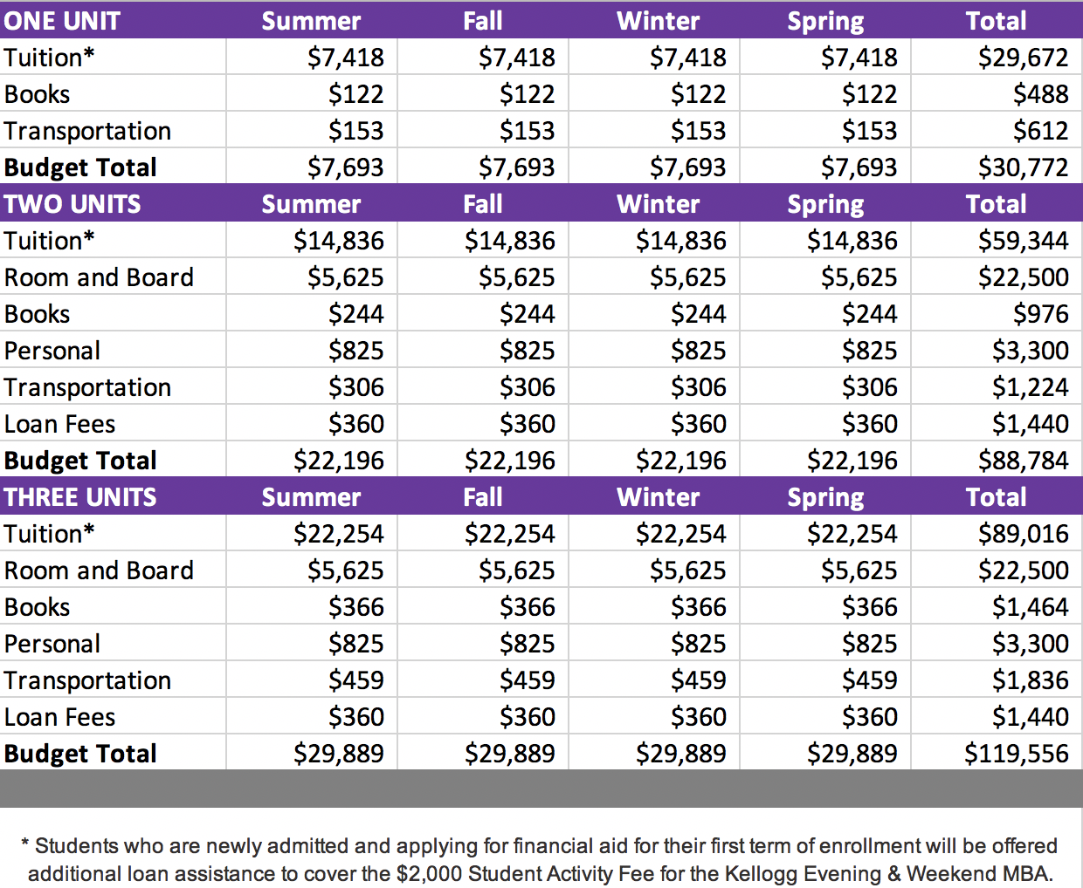
- COMPANY’s Investment
Financial Commitment (if applicable)
In addition to your support of my taking the time to pursue my Evening & Weekend MBA at Kellogg, I’m asking for your financial support, totaling [INSERT total amount].
Below is suggested messaging to support your case for financial support:
- Specific rationale behind the total amount you’re requesting from your employer, including how the money will be used and why (ex. travel, global elective courses to develop specific skillset, etc.)
- Some employers receive a tax benefit for providing support to employees for education benefits. Inquire with your HR department to learn more.

- Summary
Thank you for your continued support of my professional development and for considering sponsoring my attendance in Kellogg’s Evening & Weekend MBA Program. Your sponsorship will not only support my ability to advance my professional development goals, but it will allow me to continue to advance [COMPANY’s] goals and mission.
Please let me know if you have any questions. You may also contact eveningweekendmba@kellogg.northwestern.edu if you have any questions about the program and its benefits.
Lastly, in addition to your support of my attendance and time commitment, I welcome any alternative options you might have to the sponsorship format I’ve outlined above.
I respectfully request that you share your sponsorship decision with me by [INSERT date].
If [COMPANY] agrees to sponsor me and supports my decision to attend Kellogg’s Evening & Weekend Program, I will [INSERT any next steps you’ll be taking related to admission to Kellogg, including application submission deadline.]
I’ve included the following supplementary materials for your review to help inform your decision.

- Appendix
This appendix includes the following supporting materials:
- Student testimonials
- Media coverage for Kellogg’s Evening & Weekend MBA Program
- Full course offerings
- Current companies that provide sponsorship
Feel free to also include an acceptance letter (if applicable) or any other supporting documents you believe will support your case.
Student Testimonials
- Ben Preston ’21 started the E&W program and his own entrepreneurial venture, Gearflow, at the same time. He feels that his MBA and his access to the Kellogg network, mentors and classes have been critical to his startups success.

- Todd Dorsey ’20 traveled from across the United States every weekend to participate in the E&W program. While the weekend travel meant personal sacrifice including his wife and two young kids, it was a small price to pay for world-class learning with an incredible network of students and the flexibility to choose classes that would most benefit his career.

- Varsha Nagaraj ’23: “I chose Kellogg because it’s a school built on the value of collaboration. It develops leaders who are not focused on their own growth, but leaders who will work hard to incite growth in other people, their teams and their communities. Each course at Kellogg is designed with a team-oriented, learning approach, demanding students to work together in order to achieve our goals. Naturally, this builds leadership skills along with the tools needed to collaborate and foster team success. All of which I’ve been able to bring back to my own role, and teams, every day!”

- Devin Tyler ’23: “The Evening and Weekend Program was the best fit for me because it allows me to immediately apply what I’m learning in the classroom to the real-world work that I do in my career. As a management consultant, my job is to help organizations solve complex problems. To do this effectively, you have to learn and apply both critical and creative thinking skills. In Kellogg, you’re surrounded by professors and classmates who represent diverse professional backgrounds and they are often willing to share their perspectives, experiences and insights. When you add the depth of study and rigor of each class, this becomes a wealth bank for innovative thinking, identifying best practices, and sharpening analytical skills. In this program, I’m able to learn and master a new concept one day and be prepared on the next day to utilize it in the work that I do.”

- Jordan Mann ’21: “The support I feel from both the Evening & Weekend Women’s Business Association and the Kellogg community as a whole has been constant. In March 2020, we created a position for the WBA board focused on allyship. This VP and her committee have been focused on enhancing our partnerships with male allies (also known as Manbassadors) and other affinity clubs at Kellogg. And we not only had events for under-represented communities in venture capital, but we also had a group discussion about race co-hosted by Kellogg’s Evening & Weekend Black Management Association and Hispanic Management Association. I’m very grateful that WBA has given me an avenue to explore and develop these skills.”
Recent Media Coverage for Kellogg’s Evening & Weekend MBA Program

How Kellogg’s Part-Time MBA Became A Model In The Covid Era: https://poetsandquants.com/2020/05/20/how-kelloggs-part-time-mba-became-a-model-in-the-covid-era/

Kellogg Chronicles: Finance, Motherhood, Or An MBA? I Chose All Three https://poetsandquantsforexecs.com/2021/03/28/kellogg-chronicles-finance-motherhood-or-an-mba-i-chose-all-three/
Kellogg Evening & Weekend Program Full Course Offerings
Please refer to the links below to obtain the list of the most current offerings.
Core and Elective Offerings: https://www.kellogg.northwestern.edu/programs/part-time-mba/academics/curriculum.aspx
Majors & Pathways: https://www.kellogg.northwestern.edu/programs/part-time-mba/academics/majors.aspx
Current Companies that Provide Sponsorship (sample list)

- BMO Harris Bank
- Baxter International
- Discover Financial Services
- Google
- Kraft Heinz Company
- Mars
- McMaster-Carr
- Northern Trust Corporation
- PepsiCo
- Wrigley

